Tool for mapping change process and outcomes
The tool is designed to facilitate planning and documenting change processes and outcomes for professional development and research purposes. The tool draws on the Activity Network and Teacher Agency for Inclusion models to map educational practices in relation to particular objectives (e.g. closing the attainment gap), using particular approaches (e.g. Inclusive pedagogy), while accounting for contextual variation of issues, actors and environments. The model components are represented in figure 1 and described below:
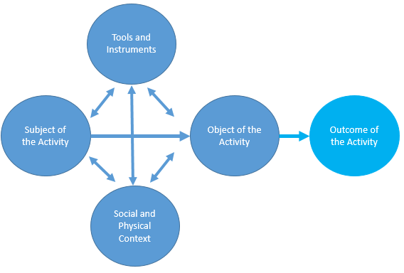
Figure 1: Network activity model
Subject refers to the person or persons that is/are carrying out the activity. The activity is understood and analysed from his/her perspective (e.g. individual teachers or all school staff).
Object refers to the focus of the activity; it defines what the activity is directed towards. This can be another person, a problem or a topic (e.g. developing teacher agency for inclusion).
Outcome refers to all wanted and unwanted results or impacts that are created as a result of carrying out an activity (e.g. achievement, wellbeing, collaboration, participation in reserach).
Tools and Instruments are physical and cognitive tools that are used to carry out the activity (e.g. workshops, research papers, strategies, policies and indicators or monitoring tools).
Context refers to the characteristics of the social setting or environment in which the activity is carried out (e.g. social norms or rules, school ethos, support systems or physical spaces).
Example of how the tool is used for professional development and research
- Identification of the desired change or outcome is the first step in the change mapping process. This can be part of an external change agenda that schools and teachers seek to ‘implement’ or a practitioner-identified need for change, or a combination of the two.
In this example a teacher from an Edinburgh-based secondary school invited us to support the change process in her school aiming at ‘closing the attainment gap while providing rich and diverse learning experiences and positive relationships that we value’.
- Subject: who carries out the activity? The tool can be used for mapping any kind of activity at any level, e.g. individual teacher, school, local authority or country.
In this example the teacher led a series of consultations with the school colleagues and the head teacher. As a result a working group was formed of all the teachers from the school who expressed an interest in participating.
- Object or focus of the activity is defined by the subject in relation to the outcome. This can be done collaboratively between practitioners and researchers.
In our example, the school staff and head teacher after discussions with the researchers decided to focus on developing students’ critical literacy and teacher agency for working inclusively with all students (rather than focusing on some).
- Tools and Instruments can be any kind of ‘intervention’ that might be put in place and/or tools for collecting and analysing evidence about change in outcome.
This school invited the university staff to conduct workshops on critical literacy and inclusive pedagogy, and provide tools for documenting change in teacher agency over time (survey and reflective log focusing on teachers’ beliefs, practices and interaction with others). The next step is to define the ways of linking change in teachers’ practices to student outcomes.
- Context refers both to the broader institutional context or policy (e.g. Improving attainment strategy and GIRFEC in Scotland) and to the relational school environment that is partly shaped by the staff and students themselves.
In this project, we are aiming to ‘make visible’ how the school social contexts are partly shaped by the teachers and other school staff themselves through their day-to-day interactions with each other, with students and their families, and others in the community.
For professional development purposes the tool is used to facilitate teachers’ individual and collective professional reflection. It helped teachers and members of the management plan and reflect on their professional development goals in relation to a particular focus and commonly agreed outcome or direction of change. It also can create opportunities to negotiate the meaning of their individual and collective purposes and practices as agents of change within given community and broader policy contexts.

The tool was originally developed for the Council of Europe by Hollenweger, J., Pantić, N. & L. Florian (2015). Tool to Upgrade Teacher Education Practices for Inclusive Education. Strasbourg: Council of Europe. Available at: http://pjp-eu.coe.int/en/web/inclusive-education/documents
The theoretical framework underpinning the tool is described in: Pantić, N. & Florian, L. (2015). Developing teachers as agents of inclusion and social justice. Education Inquiry, 6(3), 333-351.
The example is from the ESRC Impact Acceleration project ‘Making Visible Teacher Agency for Inclusion’.

